HOME AUTOMATION VIA BLUETOOTH

AIM:

TO CONTROL HOME APPLIANCES USING SMARTPHONE

COMPONENTS:

Arduino UNO

HC-05 Bluetooth Module

10 kΩ Resistor

20 kΩ Resistor

1. kΩ Resistor × 4

2N2222 NPN Transistor ×4

1N4007 Diode × 4

12 V Relay ×4

Prototyping board (Bread Board)

Connecting wires

12 V Power Supply

Smartphone (Bluetooth enabled)

CIRCUIT DIAGRAM

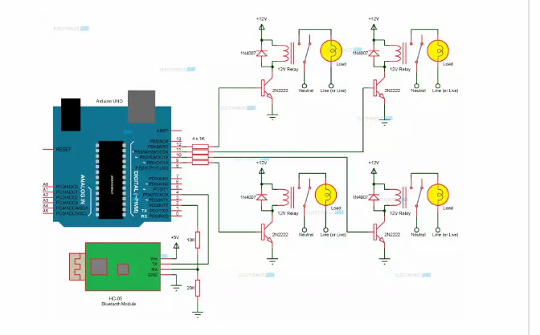

HC-05 BLUTOOTH MODULE:

The module has 4- pins VCC, TX, RX and GND.

The range of this module is approximately 10 meters.

4-CHANNEL RELAY BOARD:

It has components like base current limiting resistors, fly back diode and led indicators for connecting to devices.

WORKING PROCESS:

When the power is turned on the connection LED on the Bluetooth module starts blinking. We need to pair up with the module. Now in the controller app we need to set different keys for different loads and their corresponding value that must be transmitted when that key is pressed. When key is pressed the data transferred to Arduino and transmits to load.

APPLICATIONS

The project can be further expanded to a smart home automation system by including some sensors like light sensors, temperature sensors, safety sensors etc.

Using this we can control the appliances remotely.

Cost estimation: